Documentation for Approval Settings.

Step 1: Click the Project Settings option on left Side.

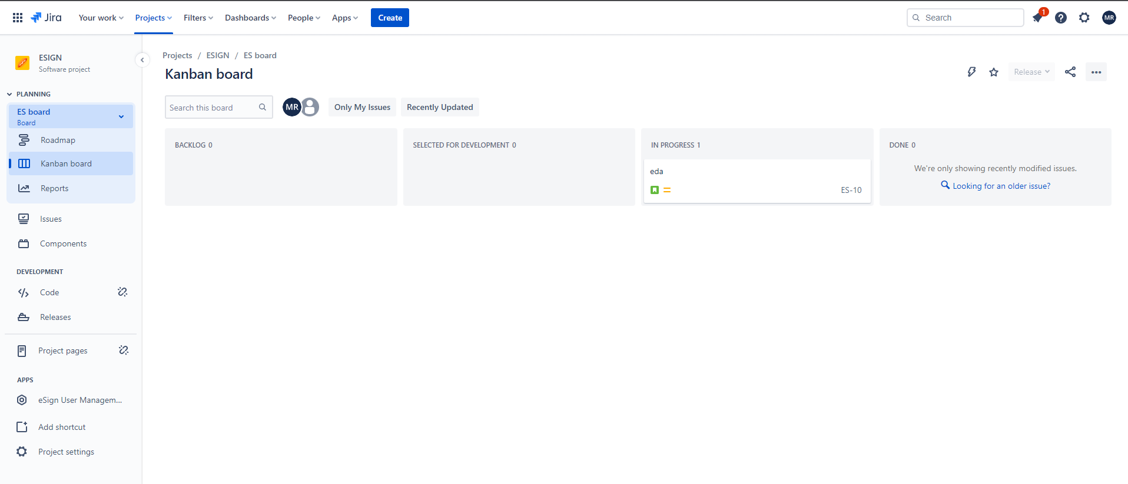

Step 2: Select the Apps Option on the left side.

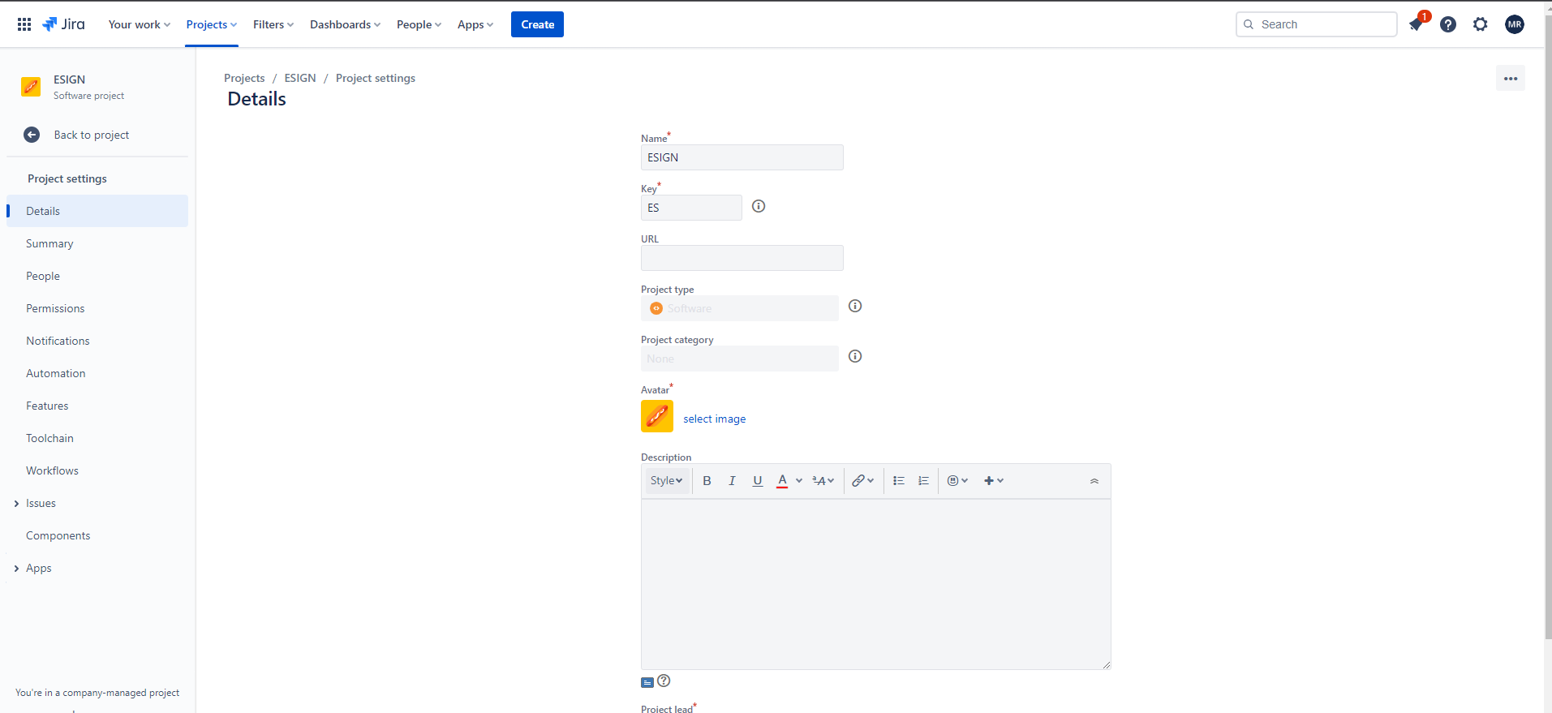

Step 3: Click on Approval Settings Option.

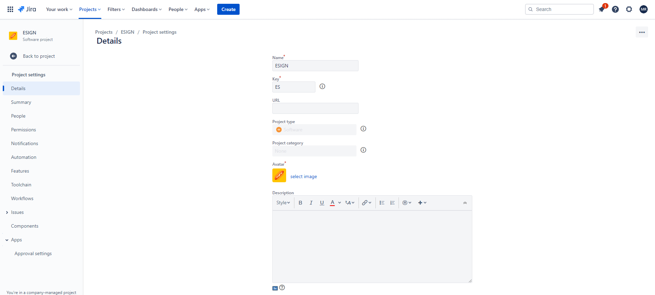

Step 4: The Approval settings window Appears. If you want to Add Approval Workflow Click on Add Approval Workflow Option on Left Side. 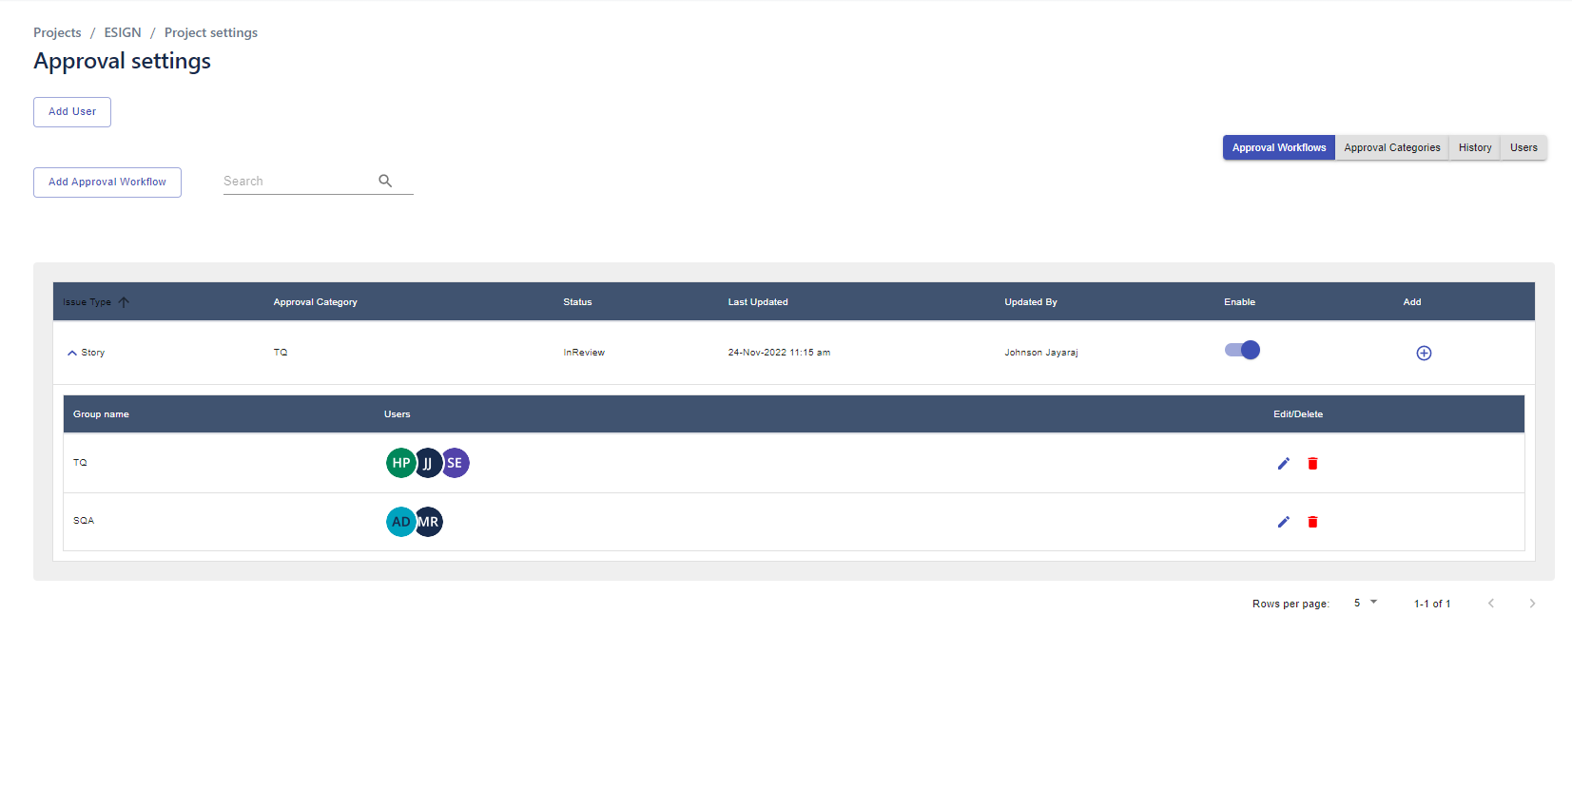

Step 5: Fill the Issue Type, Status, On Approval Transition, On Reject Transition, Category, Approval Role, Approvers and Click Create.

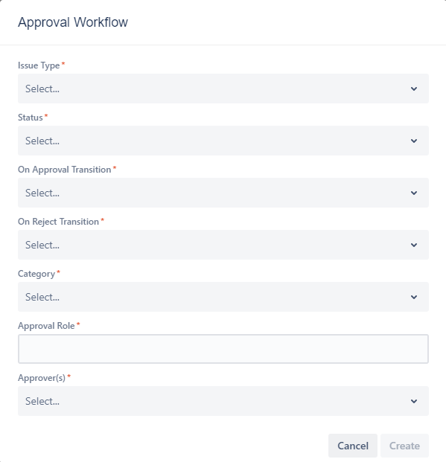

Step 6: If you want to Create a new approval category. Click on the Approval Categories on right side and then Click Add Approval Categories.

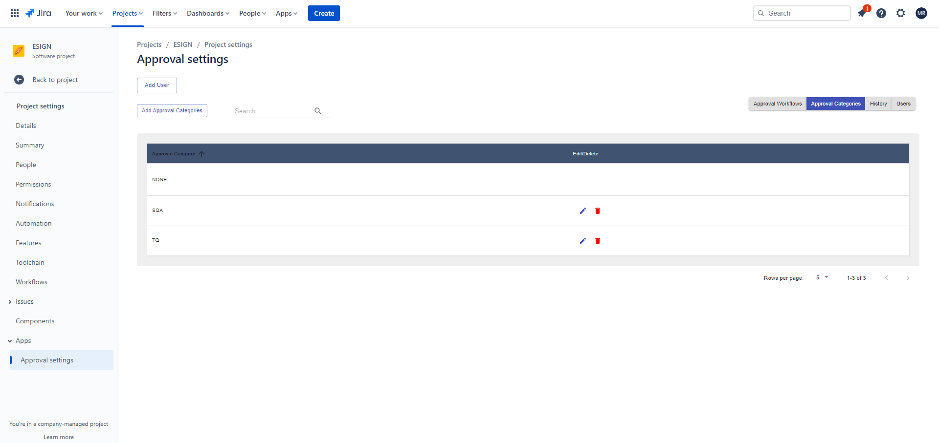

Step 7: The Category Prompt is appears.

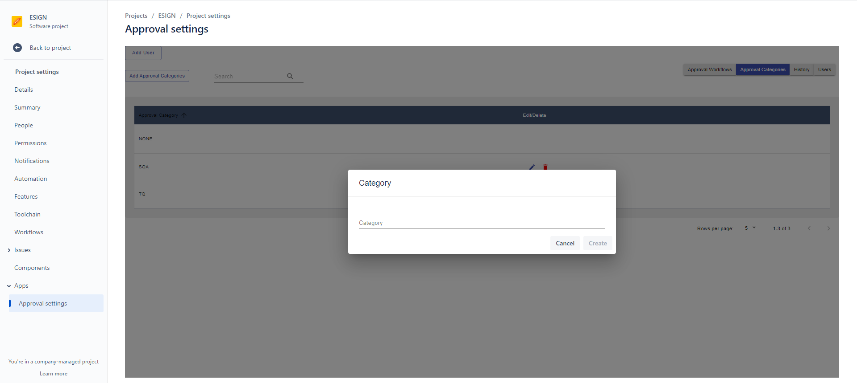

Step 8: Fill the Category Name and then Click Create Button.

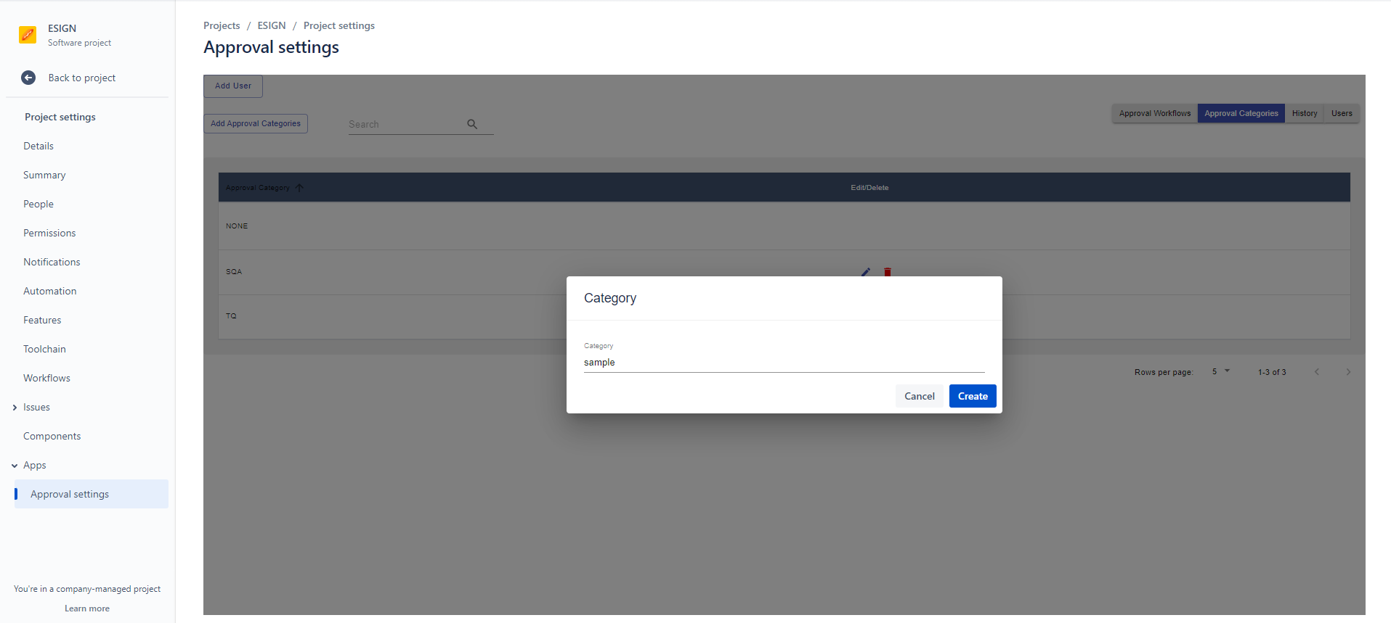

Step 9: New Category Name are Shown Below:

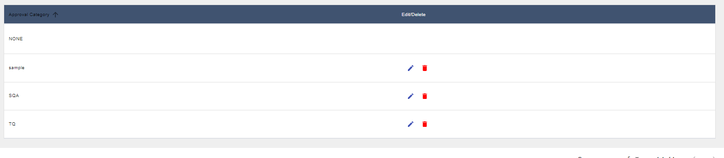

Step 10: If you want to add Users Click on the Users tab on Right side and then click add user on left side.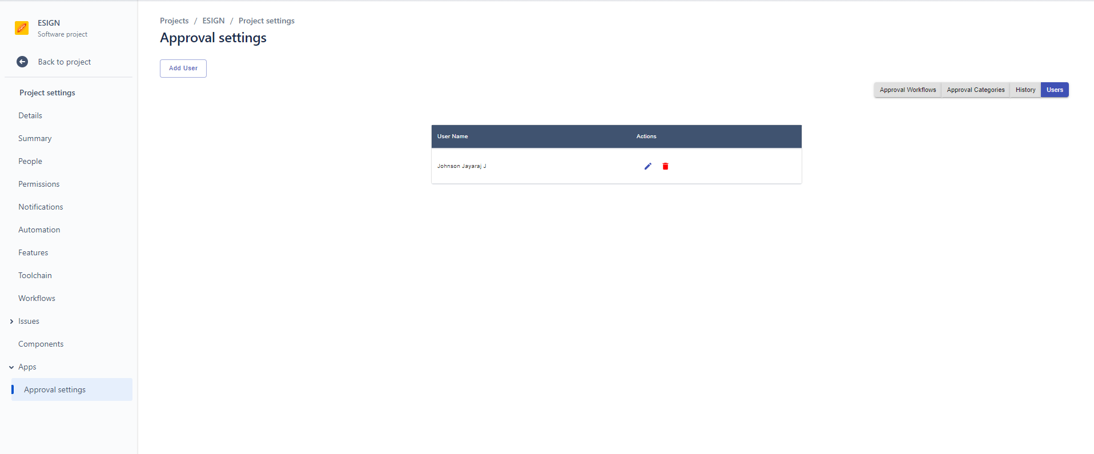

Step 11: Fill the add user Form with Display name and Strong Password and click add Users.

